HVAC Guide Specifications
Air to Air Energy Recovery Ventilator

Section 15700 – Mechanical HVAC

Size Range:
305 to 1200 nominal cubic feet per minute

Daikin AC Model Number:
VAM300GVJU
VAM470GVJU
VAM600GVJU
VAM1200GVJU

Part 1 – GENERAL

ENERGY RECOVERY VENTILATOR

  - SYSTEM DESCRIPTION
The fresh air ventilation system shall consist of the Daikin VAM-GVJU series energy recovery ventilator, incorporating a high-efficiency paper, cross-flow heat exchanger core in order to provide both sensible and latent heat recovery.

  - QUALITY ASSURANCE
- The units shall be tested by a Nationally Recognized Testing Laboratory (NRTL), in accordance with ANSI/UL 1995 – Heating and Cooling Equipment and bear the Listed Mark.
- All wiring shall be in accordance with the National Electric Code (NEC).
- The system shall be certified in accordance with Air Conditioning, Heating, and Refrigeration Institute’s (AHRI) Standard 1060 and bear the AHRI Certified label.
- The heat exchanger core shall be tested in accordance with Underwriters Laboratories (UL) 723 and shall have a flame spread rating of not more than 25, and a smoke developed rating of not more than 50.
- The system will be produced in an ISO 9001 and ISO 14001 facility, which are standards set by the International Standard Organization (ISO). The system shall be factory tested for safety and function.

  - DELIVERY, STORAGE AND HANDLING
- Unit shall be stored and handled according to the manufacturer’s recommendations.

Part 2 – WARRANTY

2.01 STANDARD LIMITED WARRANTY
Daikin North America LLC warrants original owner of the non-residential building, multifamily residence or residence in which the Daikin products are installed that under normal use and maintenance for comfort cooling and conditioning applications such products (the “Products”) will be free from defects in material and workmanship. This warranty applies to compressor and all parts and is limited in duration to ten (10) years starting from the ‘’installation date’’ which is one of the two dates below:
- The installation date is the date that the unit is originally commissioned, but no later than 18 months after the manufacture date noted on the unit’s rating plate.
- If the date the unit is originally commissioned cannot be verified, the installation date is three months after the manufacture date.

Complete warranty details available from your local Daikin representative or at www.daikincomfort.com –

Part 3 – PERFORMANCE

3.01 PERFORMANCE
The energy recovery ventilator units shall be based on nominal airflow conditions:

System Model | Nominal Airflow  (CFM) | External Static  (in. H₂O)  EX-H/H/L
VAM300GVJU | 305 | 0.64 / 0.26 / 0.16
VAM470GVJU | 470 | 0.73 / 0.39 / 0.33
VAM600GVJU | 600 | 0.76 / 0.34 / 0.32
VAM1200GVJU | 1200 | 0.56 / 0.16 / 0.24

Performance characteristics shall be certified to AHRI Standard 1060 and be based on the following conditions:

- The cooling effectiveness shall be based on 95°F DB / 78°F WB for the entering supply air and 75°F DB / 63°F WB for the entering exhaust air, at a leaving supply airflow of both 100% and 75% of the rated airflow.

- The heating effectiveness shall be based on 35°F DB / 33°F WB for the entering supply air and 70°F DB / 58°F WB for the entering exhaust air, at a leaving supply airflow of both 100% and 75% of the rated airflow.

Performance Characteristics
Mode | Air Flow | Effectiveness Type | VAM300GVJU | VAM470GVJU | VAM600GVJU | VAM1200GVJU
Heating | 100% | Sensible | 60 | 62 | 68 | 68
Heating | 100% | Latent | 46 | 48 | 42 | 42
Heating | 75% | Sensible | 63 | 66 | 72 | 72
Heating | 75% | Latent | 53 | 55 | 47 | 47
Cooling | 100% | Sensible | 60.6 | 63 | 68 | 68
Cooling | 100% | Latent | 29 | 30 | 34 | 34
Cooling | 75% | Sensible | 63.9 | 67 | 72 | 72
Cooling | 75% | Latent | 40 | 38 | 37 | 37

* Certified in accordance with the AHRI ERV Certification Program, which is based on AHRI Standard 1060. Certified units may be found in the AHRI Directory at www.ahridirectory.org.
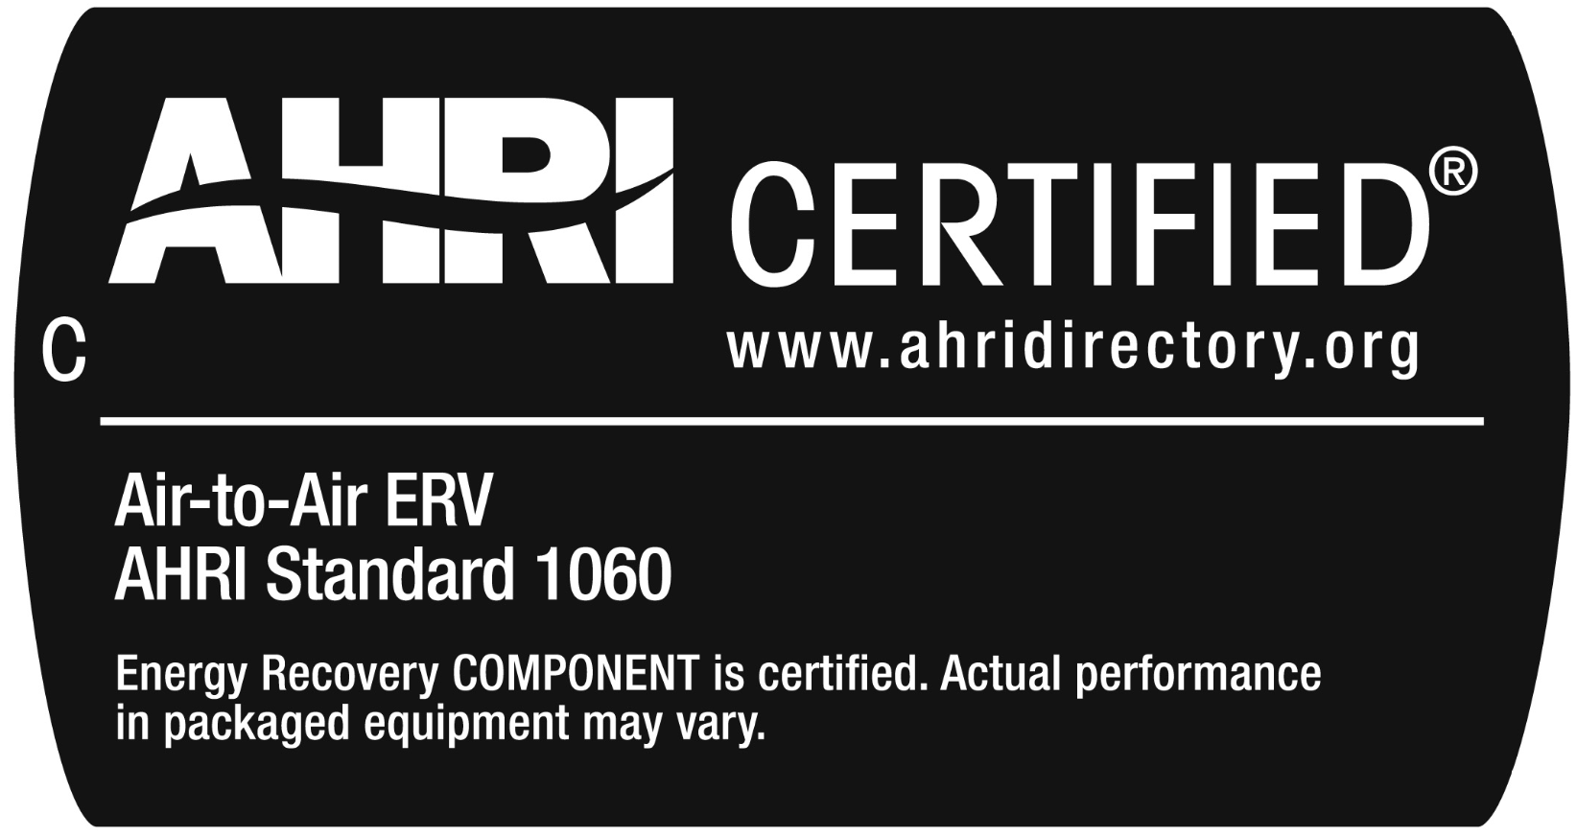

3.02 OPERATING RANGE
The equipment operating range shall be 5°F DB ~ 122°F DB* and 80%RH or less.

*Performance characteristics certified to AHRI Standard 1060 are only applicable to the specified cooling and heating operation conditions, as specified within the performance table in this document.

Part 4 – PRODUCTS

4.01 ENERGY RECOVER VENTILATOR
A. General:
The fresh air ventilation system shall consist of the Daikin VAM-GVJU series energy recovery ventilator, incorporating a high-efficiency paper, cross-flow heat exchanger core in order to provide both sensible and latent heat recovery.
- Unit Cabinet:
- The cabinet shall be constructed of galvanized steel plate.
- The unit shall be internally insulated with a self-extinguishing urethane foam.
- Fans:
- The fans shall be direct-drive, forward-curved centrifugal type with statically and dynamically balanced impellers with extra-high, high, and low fan speeds.
- The fan motor(s) shall operate on 208-230 volts, 1 phase, 60 hertz.
- The air flow rate shall be available in extra-high, high, and low settings.
- The fan motor shall be thermally protected.
- Filter:
- The supply and exhaust air streams shall be filtered prior to entering the heat exchanger core by means of a multidirectional fibrous fleece filter.
- Heat Exchanger:
- The heat exchanger element shall consist of a specially processed, nonflammable, HEP (high efficiency paper) heat exchanger designed to allow the exchange of both sensible and latent energy between the supply and exhaust airstreams. The core material shall be tested as specified in UL 723 and have a flame spread rating of not more than 25, and a smoke developed rating of not more than 50.
- Electrical:
- A separate power supply will be required of 208-230 volts, 1 phase, 60 hertz. The acceptable voltage range shall be 187 to 253 volts.
- Transmission (control) wiring between the indoor unit and remote controller shall be a maximum distance of 1,640 feet.
- Control:
- The unit shall be compatible with Daikin D-III net via the F1/F2 terminal.
- The unit shall be capable of the following methods of control:
    - Independent control – The unit shall be operable directly by a local remote controller.
    - Interlocked control – The unit shall be operable in conjunction with a VRV or Sky Air system by a local remote controller.
    - Centralized control – The unit shall be operable by a centralized control without the need for a local remote controller to be connected.
- The unit shall be capable of the following modes of operation:
    - Energy recovery
    - Bypass ventilation – The unit shall be capable of bypass ventilation which diverts air flow around the heat exchanger core. No energy recovery is performed.
    - Auto Mode – The unit shall be capable of automatically determining the need for performing energy recovery or bypassing the heat exchanger core based on the current fan coil operation mode and the current indoor and outdoor temperatures.
    - Fresh-up Mode (supply) – The unit shall be capable of entering Fresh-up Supply operation in which the incoming supply air ratio is greater than the exhaust air ratio.
    - Fresh-up Mode (exhaust) – The unit shall be capable of entering Fresh-up Exhaust operation which in the incoming supply air ratio is less than the exhaust air ratio.
    - Night Time Free Cooling – The unit shall be capable of Night Time Free Cooling in which the unit will automatically energize to lower the space temperature based on the current outdoor temperature, the current indoor temperature, current set point, and the operating state of the indoor fan coils.
- Installation
- The unit shall be capable of inverted installation if required by ductwork and access clearance requirements.
- The unit shall not require a condensate drain connection or condensate pan of any kind.
- Accessories Available
- Replacement air filter.
- DCS601C71 – I-Touch Controller
- DCM601A71 – I-Touch Manager
- DCS302C71 – Central Remote Controller
- DCS301C71 – Unified On/Off Controller
- DST301BA61 – Schedule Timer
- BRC1E_ - Navigation Remote Controller
- KRP4A72 – Group Control Adaptor PCB
- KRP50-2 – PC Board Adaptor for Humidifier
- KRP50-2A90 – Installation box adaptor for PCB

